Please be advised that no application will be accepted after 4:30 PM on the scheduled filing date; refer to Form 108 for filing deadlines and meeting dates. No application will be considered as filed in an acceptable manner if any of the required application materials are inaccurate or incomplete, and such applications will be returned and will not be accepted for that month. If an applicant desires to amend his application, a completely new application may be required. No exceptions will be made. Please check with the planning staff if you have any questions regarding the application. Do this prior to the filing deadline if you expect to make corrections in time to file.

IMPORTANT: Legal counsel has advised that all information and exhibits regarding this application shall be attached to this application or presented to the Planning Commission at the public hearing. Direct individual contact with commissioners should not occur.

Zoning Map Amendment Procedures

1. Applicant secures necessary materials from the Planning Office -- this application form and any other necessary information.

2. Applicant submits complete and accurate application materials to the Planning Office, as summarized in the table at right.

3. Zoning Change Sign. The planning staff will place zoning change sign(s) on the property, visible from the road, 14 days before the scheduled public hearing, as required by state law. The sign(s) must remain in place until the public hearing occurs.

4. Staff Report. The planning staff will review the application and prepare a staff report including recommendations, conditions, and findings of fact. The report is forwarded to the OMPC, the applicant, and/or the applicant's attorney, one week before the scheduled OMPC public meeting.

5. Applicant responds by letter upon receipt of the staff report, if he desires to postpone or withdraw the application.

6. Legal Notice of Public Hearing will appear in the local newspaper at least seven (7) days before the public hearing. After publication, only OMPC action can permit postponement or withdrawal of the application. The Messenger-Inquirer will directly bill the applicant for the cost of advertising.

Application Materials to Submit
ITEMS | COPIES | PAGE
Property Information Drawing | 20 | 2
Certified Letters with Postage | As needed | 3, 4
Applicant Information | 2 | 5
Filing Fee | 2 | 5
Applicant & Owner Certifications | 2 | 5
Legal Description of Property | 2 | 6
No Deed Restrictions Certification | 2 | 6
Location Status | 2 | 6
List of Adjoining Property Owners | 2 | 7
Applicant's Findings for Zone Change | 2 | 8
Development Plan (if required) | 2 | Below
Development Plan. Zone changes to B-1, B-3 and MHP require the submission of a preliminary development plan in conjunction with the zoning map amendment application. Other zone changes may require the submission and approval of a preliminary development plan, a final development plan, or both, at the discretion of the OMPC. In such cases, the OMPC may postpone action on the map amendment proposal for up to sixty (60) days or until the applicant submits a development plan. If a plan is not submitted during this time period, the OMPC may recommend to the legislative body that the map amendment be approved subject to the submission of a development plan at a future date. When a development plan is required, building activity cannot commence until a final development plan is approved by the OMPC.

7. Public Hearing will be held by the OMPC generally on the second Thursday of each month at Owensboro City Hall. After hearing all comments, the OMPC will either act to permit withdrawal, postpone action, or recommend approval or disapproval to the appropriate legislative body: Owensboro City Commission, Daviess County Fiscal Court, or Whitesville City Commission. If the OMPC recommends approval subject to a development plan or other material not submitted prior to OMPC final action, such must be acted upon by the OMPC before development activity on the subject property may move forward.

8. OMPC's Recommendation and Findings will be forwarded to the legislative body. The recommendation of the OMPC will automatically become effective 21 days after action unless the appropriate legislative body or an aggrieved person files written notice to the OMPC requesting the application to be decided by the appropriate legislative body.

9. Legislative Body, if to decide the application, will after receiving the recommendation, findings and transcribed minutes of the OMPC, will review the records, schedule two readings, and take action. At the second reading, the legislative body may permit the applicant's attorney or others to make statements pertinent to the record. The legislative action becomes effective with legal publication in the local newspaper or legislative body final action, whichever occurs last.

Property Information Drawing

Submit twenty (20) copies of the drawing illustrated in the sample below.

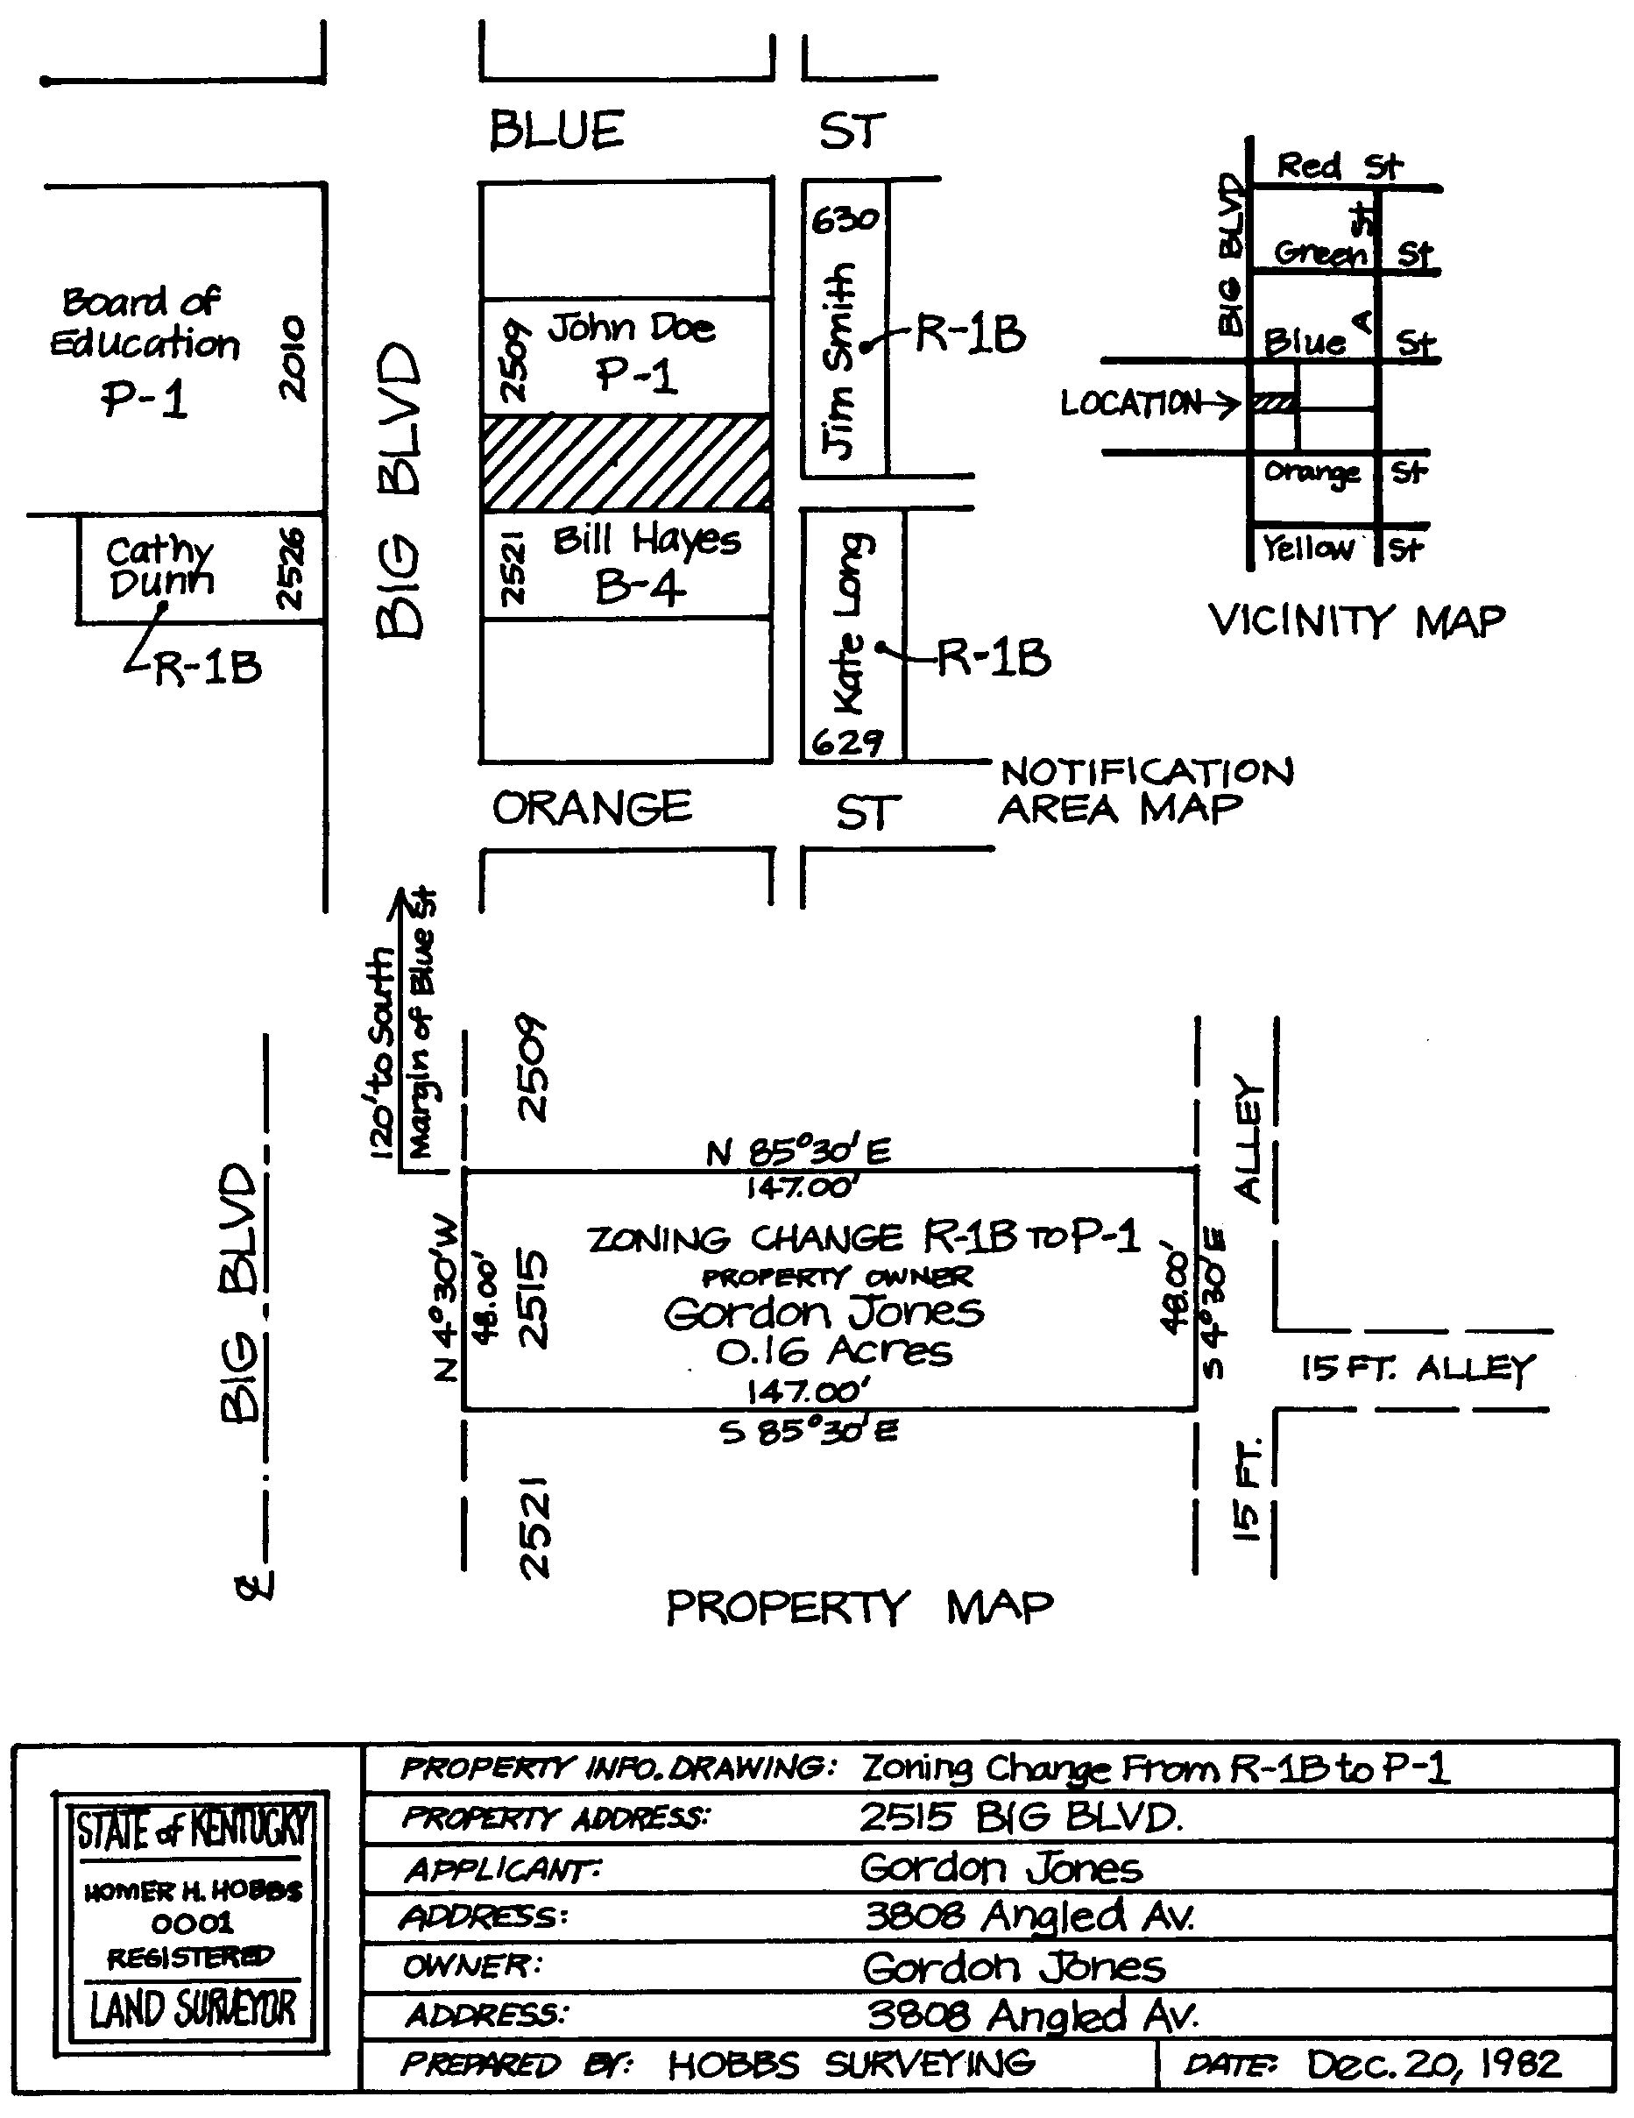A Property Information Drawing must be prepared by a registered civil engineer or registered land surveyor. A page size of 8½" x 11" shall be used unless legibility and clarity require a larger size. The sample below (not to scale) shows the required contents of the Property Information Drawing.

Must be prepared by registered civil engineer or registered land surveyor. Maximum page size: 8½" x 11" unless larger size is necessary for clarity. Submit twenty (20) copies of the drawing.

REQUIRED CONTENTS:

- Vicinity Map showing enough of the neighborhood to permit quick recognition of property's location.

- Notification Area Map showing the owner's names, addresses and zoning of all properties adjoining the subject property, including those across public rights-of-way.

- Property Map showing the boundaries with bearings and dimensions, acreage and access streets for the subject property, along with address, owner's name, and zone change requested.

- Title Box showing the information in the sample at right.

- Orient north to the top of the drawing.

Certified Letters with Postage

The applicant is required to prepare letters and address envelopes to be sent to the owner(s) of each property adjoining the subject property, including properties directly across streets and other public rights-of-way. The letters will notify adjoining property owners of the applicant's request for a zoning map amendment as well as the date, time and place of the public hearing regarding the application. Adjoining property owners' names and mailing addresses are included on the Property Information Drawing, Page 2, and in the List of Adjoining Property Owners on Page 7.

All letters must be typewritten and are submitted with the filing of the application. On Page 4 is a form letter that should be used. Fill in all blank lines EXCEPT for the addressee's name and address (at top left of the letter). When filling in Item #3 on the letter, use full zone name and description as shown in the table on Page 5. Then photocopy the number of letters needed. Finally, fill in the name and address on each letter for each adjoining property owner to be notified. The OMPC Director will sign the letters after the application is submitted.

Use plain envelopes, addressed to each adjoining property owner. Make certain to put the OMPC's return address in the upper left-hand corner of each envelope!

Owensboro Metropolitan Planning Commission
Post Office Box 732
Owensboro, KY 42302-0732

DO NOT seal envelopes. Instead, leave them open for planning staff to check. Place the appropriate letter inside each envelope.

Complete Certified Mail as follows:

1 Complete receipt for certified mail for each envelope as shown at right. DO NOT affix to envelope.

2 Complete Domestic Return Receipt card for each envelope as shown at right. DO NOT affix to envelope.

3 Affix *TOTAL in postage stamps on upper right hand front of each envelope. DO NOT use postage meters. NO CHECKS to postmaster for certified mail. See table at lower right for current postal rates.

4 Paper-clip each completed receipt and card to the appropriate envelope. Submit the UNSEALED letters with the other application materials.

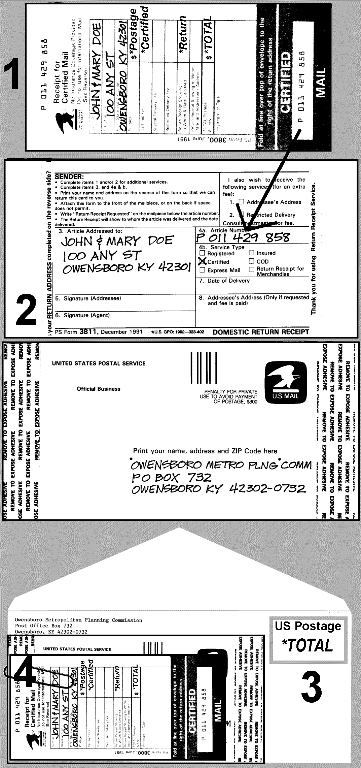

Current Postal Rates
*Postage 1st ounce | $0.55
*Certified Mail | $3.55
*Return Receipt | $2.85
*TOTAL | $6.95

TO: | Application  Filing Date:
This letter is being sent to inform you that the owner of property adjoining yours has requested the Owensboro Metropolitan Planning Commission to hold a public hearing on changing the zoning classification of his property. While the date for the public hearing has been set (see #9 below), an occasional withdrawal or requested postponement may occur. If this happens, the planning staff will make every effort to contact the adjoining property owners. The recommendation of the Owensboro Metropolitan Planning Commission will automatically become effective 21 days after action unless the appropriate legislative body or an aggrieved person files written notice to the OMPC requesting the application to be decided by the appropriate legislative body. Request forms for legislative body to decide zoning change are available in the OMPC office.
1. Address of property requested for zone change...........
2. Acreage involved..........................................................
3. Zone change requested................................................ | From:
 | To:
4. Owner/Co-Applicant of property for zone change.........
5. Address of Owner/Co-Applicant....................................
6. Name of zone change Applicant...................................
7. Zone Change Applicant is using the following attorney..
8. Address & telephone of… | Address:
Applicant Applicant's attorney....
 | Phone:
9. Tentative date of public hearing meeting........................
10. Time and place of meeting............................................ | 5:30 PM, 4th Floor Auditorium  Owensboro City Hall, 101 East 4th Street  Owensboro, KY
If you should desire any additional information about this zone change request, please feel free to contact me or any other member of the planning staff at the OMPC offices, or call 270-687-8650. A staff report and recommendation will be available the Monday before the Thursday hearing. Legal counsel has advised that all information and exhibits regarding this application shall be attached to this application or presented to the commission at the public hearing. Direct individual contact with the commissioners should not occur.
Enclosure: Summary of Zoning Change Process | Respectfully,
 | Brian R. Howard, AICP, OMPC Director

Applicant Information

In filling out this form, please note that the term Owner / Co-Applicant is used to denote that the owner of the subject property is considered to be a party to this application and that the owner has authorized its submission, even when the primary applicant is not the current legal owner of the subject property.

Date received by Planning Office

Subject Property for Zone Change
Street
Address

Existing
Zoning

Proposed
Zoning

Existing Land Use
(Be specific)

Proposed Land Use
(Be specific)

Applicant
Name

Address

Day Telephone

Property Owner / Co-Applicant
Name

Address

Day Telephone

Attorney if applicable
Name

Address

Day Telephone

Filing Fee based on proposed zone
ZONING CHANGE TO |  | FEE
A-R Rural Agriculture | A-U Urban Agriculture | $235 +  $3/whole acre
MHP Manufactured Housing | R-1A Single-Family Res
R-1B Single-Family Res | R-1C Single-Family Res
R-1T Townhouse
R-2MF, R-3MF Multi-Family Res | R-4DT Inner-City Res | $355 + $5/whole acre
P-1 Professional/Service | B-1 Neighborhood Business | $470 + $10/whole  acre
B-2 Central Business | B-3 Highway Business
B-4 General Business | B-5 Business/Industrial
I-1 Light Industrial | I-2 Heavy Industrial
# WHOLE ACRES
FILING FEE

Applicant & Owner Certifications
By the Applicant/Owner: I (We) the undersigned applicant and owner, fully understand that approval of this Zoning Amendment does not allow the applicant/owner to construct, alter, modify, or occupy a building on the subject property. The applicant/owner is responsible for obtaining all approvals as necessary, including plan review, permitting inspections and site plan drainage approval before occupancy of the building will be allowed. Please contact the Building/Electrical Division of the OMPC at 270-687-8650 prior to beginning any work on the subject property for applicable requirements.

Applicant/Owner’s Signature Date

By: ______________________________________________
Applicant

By: ______________________________________________
Owner

By the Applicant: I do hereby certify that, to the best of my knowledge and belief, all application materials are herewith submitted, and the information they contain is true and correct. I further certify that I accept responsibility for payment of advertising costs relating to this application and fully understand that the Messenger-Inquirer requires that the OMPC Hearing Notice be paid in full before the notice is published. If the applicant fails to pay for the notice when contacted by the Messenger-Inquirer the item cannot be heard by the OMPC.

PLEASE TYPE OR PRINT

Applicant's Signature Date

By: ________________________________________________

By the Owner/Co-Applicant: I do hereby certify that I am the owner of this property and authorize the submission and consideration of this application and all information herein and attachments hereto.

Owner/Co-Applicant's Signature Date

By: ________________________________________________

________________________________________________
(Please type or print name below signature)

SUBSCRIBED AND SWORN TO, before me, by

_____________________________________________________

___________________________________________________________

On this the ________ day of __________________, __________.

My commission expires ___________________________________

Notary Public _________________________________________

Legal Description of Property
A legal description of the subject property must accompany submitted application materials.

No Deed Restrictions Certification
In cases of zone change requests to industrial, business, professional, or multi-family residential zones, a letter of certification from an attorney stating there are no deed restrictions prohibiting the proposed use of the subject property must accompany submitted application materials. An attorney must certify no deed restrictions for a period of sixty (60) years for non-residential requests and for a period of thirty (30) years for residential requests.

Location Status
In this part of the application, the applicant must address the status of development patterns, environment, and urban services at the location of the subject property.

PLEASE TYPE OR PRINT

Development Patterns Status

surrounding the subject property:

North Existing Zoning _________________________
Existing Land
Use (be specific) ________________________________

East Existing Zoning ___________________________
Existing Land
Use (be specific) ________________________________

South Existing Zoning _________________________
Existing Land
Use (be specific) ________________________________

West Existing Zoning __________________________
Existing Land
Use (be specific) ________________________________

Environmental Status

of the subject property:

Floodplain Areas Yes No If Yes:

Flood Insurance Rate Map Zone ________________

Base Flood Elevation (100-Year) ________________

Floodway Areas Yes No

Known Wetlands Area Yes No

Prime Agricultural Land Yes No

Steep Slopes (greater than 16% grade) Yes No

Known Historical, Archaeological Sites Yes No

Urban Services Status

for the subject property:

Sanitary Sewage Disposal

Existing Proposed, provided by:

___________________________________________

Storm Water Drainage Easements

Existing Proposed

Storm Water Drainage Improvements

Existing Proposed

Solid Waste Disposal

Existing Proposed, provided by:

___________________________________________

Water Supply

Existing Proposed, provided by:

___________________________________________

Electricity Supply

Existing Proposed, provided by:

___________________________________________

Natural Gas Supply

Existing Proposed, provided by:

Atmos Energy Liquid propane

List of Adjoining Property Owners

The applicant must submit a list of names and mailing addresses of all persons owning property adjoining the subject property, including properties directly across streets and other public right-of-way. Use the form below. The names shall be secured from the records of the Daviess County Property Valuation Administrator (PVA) no more than thirty (30) days prior to submission of this application, and shall be referenced by street address to the street addresses on the Property Information Drawing submitted as part of this application.

In cases where a business, institution or other owner group is to be notified, please provide the name of the president, chairman or other officer of the owner group. The applicant should retain a copy of this listing, especially to ensure that certified letters notify all adjoining property owners.

Address of Property  Adjoining Subject Property | Name(s) of  Property Owner(s) | Mailing Address(es)  with Zip Codes

PLEASE TYPE OR PRINT

Applicant's Findings for Zone Change

In order for the Owensboro Metropolitan Planning Commission to make a recommendation for a zoning map amendment, it must make findings of fact in support of its recommendation. The type of facts that must be cited in support of the applicant's proposal depends on whether or not the proposal is found to be in compliance with the criteria of the adopted comprehensive plan. Below, the applicant must address either Type 1 Findings or Type 2 Findings.

Type 1 Findings - IN COMPLIANCE: If the applicant determines that his/her proposal is in compliance with the Comprehensive Plan, the applicant must cite specific facts with reference to the Land Use Criteria and/or other elements of the Comprehensive Plan in support of this determination.

Type 2 Findings - NOT IN COMPLIANCE: If the applicant determines that his/her proposal is NOT in compliance with the Comprehensive Plan, the applicant must state specific facts in support of one or both of the following:

A. The existing zoning classification given to the property is inappropriate and the proposed zoning classification is appropriate; AND/OR

B. There have been major changes of an economic, physical or social nature within the AREA involved which were not anticipated in the adopted comprehensive plan and those changes have substantially altered the basic character of the AREA involved.

Below, the applicant must address either Type 1 or Type 2 Findings in support of the Zone Change. The types of findings are described above. Attach additional sheets if more space is needed.

PLEASE TYPE OR PRINT

